## **Week 3 (Chapter 11)**

1. (New Account class) An Account class was specified in Programming Exercise 9.7. Design a new Account class as follows:
   * Add a new data field name of the String type to store the name of the customer.
   * Add a new constructor that constructs an account with the specified name, id, and balance.
   * Add a new data field named transactions whose type is ArrayList that stores the transaction for the accounts. Each transaction is an instance of the Transaction class. The Transaction class is defined as shown above:

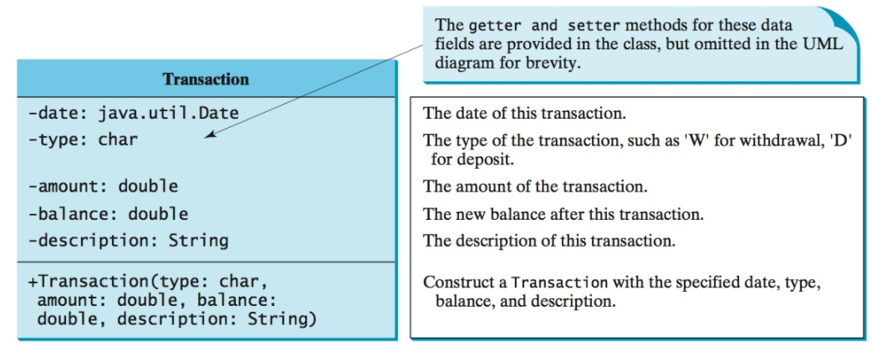

* Modify the withdraw and deposit methods to add a transaction to the transactions array list.
* All other properties and methods are the same as in Programming Exercise 9.7.
* Write a test program that creates an Account with annual interest rate 1.65%, balance 1000, id 1122, and name George. Deposit $30, $40, and $50 to the account and withdraw $5, $4, and $2 from the account. Print an account summary that shows account holder name, interest rate, balance, and all transactions.
* Exercise11_08.java

1. Show the execution of DistinctNumbers.java.
   1. This program prompts the user to enter a sequence of numbers and displays the distinct numbers in the sequence. Assume that the input ends with 0 and 0 is not counted as a number in the sequence.
2. (Smallest rows and columns) Write a program that randomly fills in 0s and 1s into an n-by-n matrix, prints the matrix, and finds the rows and columns with the most 0s. (Hint: Use two ArrayLists to store the row and column indices with the most 0s.) Here is a sample run of the program:

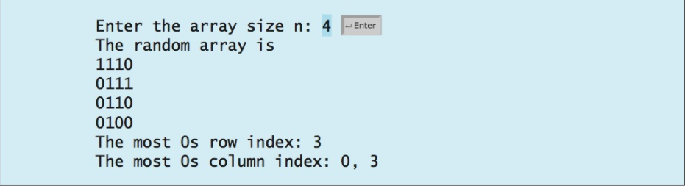

* Start with Exercise11_09_practice.java
* Then, show the solution Exercise11_09.java

1. (ArrayIndexOutOfBoundsException) Write a program that meets the following requirements:

* Creates an array with 100 randomly chosen integers.
* Prompts the user to enter the index of the array, then displays the corresponding element value. If the specified index is out of bounds, display the message **Out of Bounds.**
* Start with Exercise12_03_practice.java
* Then, show the solution Exercise12_03.java